Q1) Identify the Data type for the Following:

|  |  |
| --- | --- |
| Activity | Data Type |
| Number of beatings from Wife | Discrete |
| Results of rolling a dice | Discrete |
| Weight of a person | Continuous |
| Weight of Gold | Continuous |
| Distance between two places | Continuous |
| Length of a leaf | Continuous |
| Dog's weight | Continuous |
| Blue Color | Discrete |
| Number of kids | Discrete |
| Number of tickets in Indian railways | Discrete |
| Number of times married | Discrete |
| Gender (Male or Female) | Discrete |

Q2) Identify the Data types, which were among the following

Nominal, Ordinal, Interval, Ratio.

|  |  |
| --- | --- |
| Data | Data Type |
| Gender | Nominal |
| High School Class Ranking | Ordinal |
| Celsius Temperature | Interval |
| Weight | Ratio |
| Hair Color | Nominal |
| Socioeconomic Status | Ordinal |
| Fahrenheit Temperature | Interval |
| Height | Ratio |
| Type of living accommodation | Ordinal |
| Level of Agreement | Ordinal |
| IQ(Intelligence Scale) | Ratio |
| Sales Figures | Interval |
| Blood Group | Nominal |
| Time Of Day | Ratio |
| Time on a Clock with Hands | Ratio |
| Number of Children | Ordinal |
| Religious Preference | Nominal |
| Barometer Pressure | Ratio |
| SAT Scores | Ratio |
| Years of Education | Interval |

Q3) Three Coins are tossed, find the probability that two heads and one tail are obtained?

Answer: (HHH, HHT, HTH, THH, TTH, THT, HTT, TTT)

Probability of two head and one tail = 3/8

= 0.375

Q4) Two Dice are rolled, find the probability that sum is

1. Equal to 1
2. Less than or equal to 4
3. Sum is divisible by 2 and 3

Answer:

(1,1) (1,2) (1,3) (1,4) (1,5) (1,6)

(2,1) (2,2) (2,3) (2,4) (2,5) (2,6)

(3,1) (3,2) (3,3) (3,4) (3,5) (3,6)

(4,1) (4,2) (4,3) (4,4) (4,5) (4,6)

(5,1) (5,2) (5,3) (5,4) (5,5) (5,6)

(6,1) (6,2) (6,3) (6,4) (6,5) (6,6)

* 1. sum of the two dice is not equal to 1 so, answer is 0
  2. sum is less than and equal to 4 is = 6/36 = 1/6 = 0.16
  3. There is one more answer of (c) , outcomes are (1,5) (2,4) (3,3) (4,2) (5,1) (6,6) = 6/36 = 1/6

Q5) A bag contains 2 red, 3 green and 2 blue balls. Two balls are drawn at random. What is the probability that none of the balls drawn is blue?

Answer:

Total balls are 7

Two balls are drawn randomly = NCr = 7C2 = 7*6*5*4*3*2*1/2*1(5*4*3*2*1) =21

Here consider only red and green balls = NCr = 5C2 = 5*4*3*2*1/2*1(3*2*1) = 10 Probability = 10/21 = 0.4761

Q6) Calculate the Expected number of candies for a randomly selected child. Below are the probabilities of count of candies for children (ignoring the nature of the childGeneralized view).

|  |  |  |
| --- | --- | --- |
| CHILD | Candies count | Probability |
| A | 1 | 0.015 |
| B | 4 | 0.20 |
| C | 3 | 0.65 |
| D | 5 | 0.005 |
| E | 6 | 0.01 |
| F | 2 | 0.120 |

Child A – probability of having 1 candy = 0.015.

Child B – probability of having 4 candies = 0.20

Answer:

The Expected number of candies for a randomly selected child

= (1*0.015) +(4*0.20) +(3*0.65) +(5*0.005) +(6*0.01) +(2*0.120)

= 0.015+0.8+1.95+0.025+0.06+0.24

= 3.09

Q7) Calculate Mean, Median, Mode, Variance, Standard Deviation, Range & comment about the values / draw inferences, for the given dataset

- For Points, Score, Weigh >

Find Mean, Median, Mode, Variance, Standard Deviation, and Range and also Comment about the values/ Draw some inferences.

Answer: -

|  |  |  |  |
| --- | --- | --- | --- |
|  | Points | Score | Weight |
| Mean | 3.596563 | 3.21725 | 17.84875 |
| Median | 3.695 | 3.325 | 17.71 |
| Mode | 3.92 | 3.44 | 17.02 |
| Variance | 0.28588 | 0.95738 | 3.19317 |
| Standard  Deviation | 0.53468 | 0.97846 | 1.786943 |
| Range | 2.17 | 3.911 | 8.4 |

Q8) Calculate Expected Value for the problem below

a) The weights (X) of patients at a clinic (in pounds), are 108, 110, 123, 134, 135, 145, 167, 187, 199

Assume one of the patients is chosen at random. What is the Expected Value of the Weight of that patient?

Answer: -

|  |  |  |  |  |  |  |  |  |  |
| --- | --- | --- | --- | --- | --- | --- | --- | --- | --- |
| E(x) | 108 | 110 | 123 | 134 | 135 | 145 | 167 | 187 | 199 |
| P(x) | 1/9 | 1/9 | 1/9 | 1/9 | 1/9 | 1/9 | 1/9 | 1/9 | 1/9 |

Probability = (1/9*108) +(1/9*110) +(1/9*123) +(1/9*134) +(1/9*135)

+(1/9*145) +(1/9*167) +(1/9*187) +(1/9*199)

= 145.33 pounds

Q9) Calculate Skewness, Kurtosis & draw inferences on the following data Car’s speed and distance. (Q9_a.csv).

Answer: -

|  |  |  |
| --- | --- | --- |
|  | SPEED | DIST |
| Skewness | -0.117509861 | 0.80689496 |
| Kurtosis | -0.50899442 | 0.405052582 |
| Mean | 15.4 | 42.98 |
| Median | 15 | 42.98 |
| Mode | 20 | 26 |

SP and Weight (WT) (Use Q9_b.csv)

Answer: -

|  |  |  |
| --- | --- | --- |
|  | SP | WT |
| Skewness | 1.611450196 | -0.614753326 |
| Kurtosis | 2.977328944 | 0.950291491 |
| Mean | 121.5402722 | 32.41257691 |
| Median | 118.2086984 | 32.73451818 |
| Mode | 118.2889958 |  |

Q10) Draw inferences about the following boxplot & histogram

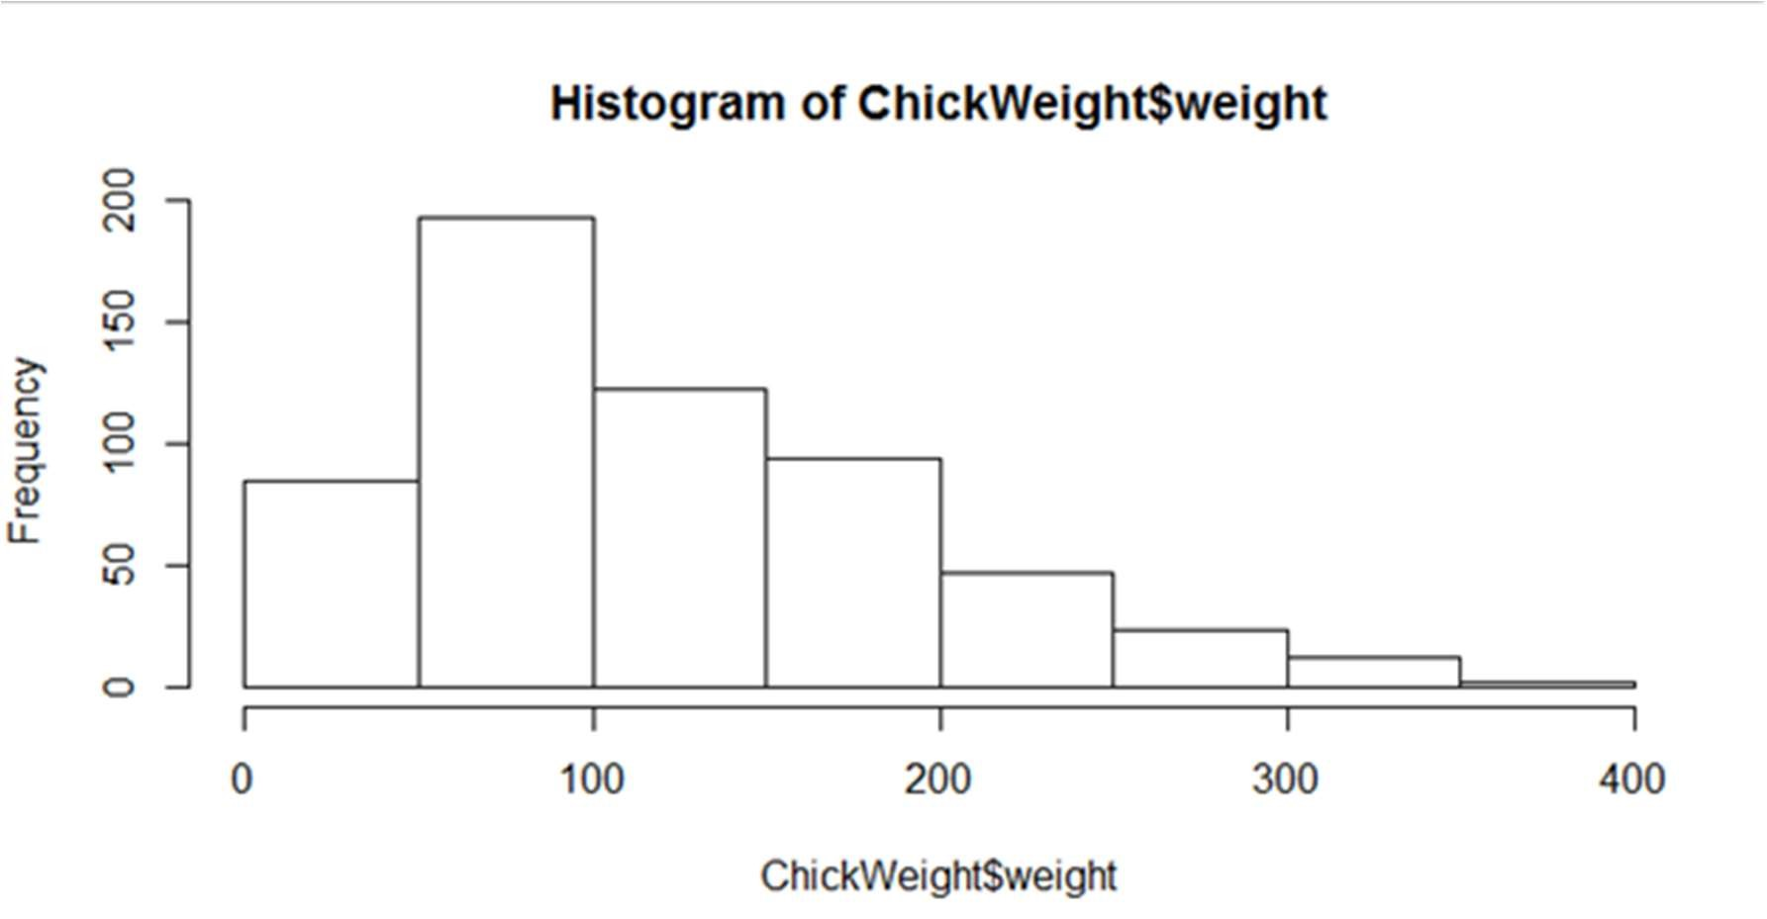

Answer: This Histogram shows Positive skewed distribution, because Mean>Median>mode.

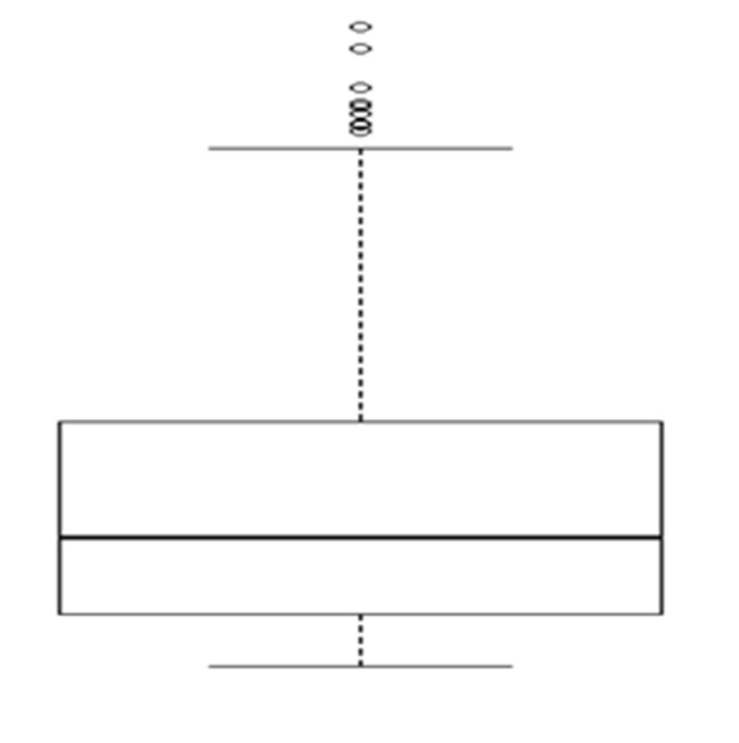

Answer: In this boxplot many(higher) outliers available of dataset.

Q11) Suppose we want to estimate the average weight of an adult male in Mexico. We draw a random sample of 2,000 men from a population of 3,000,000 men and weigh them. We find that the average person in our sample weighs 200 pounds, and the standard deviation of the sample is 30 pounds. Calculate 94%,98%,96% confidence interval?

Answer:

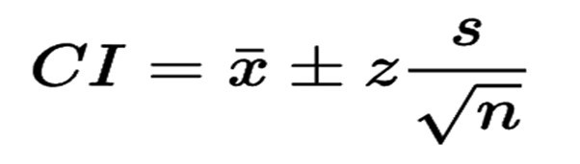

Where,

CI = confidence interval, x̅ = sample mean = 200, z = confidence level value s = sample standard deviation = 30, n = sample size = 2000

|  |  |  |  |
| --- | --- | --- | --- |
|  | 94% | 96% | 98% |
| CI | 134.89, 265.102 | 130.209, 269.790 | 122.725, 277.274 |

Q12) Below are the scores obtained by a student in tests?

# 34,36,36,38,38,39,39,40,40,41,41,41,41,42,42,45,49,56

1. Find mean, median, variance, standard deviation.
2. What can we say about the student marks?

Answer:

1.

|  |  |  |  |  |
| --- | --- | --- | --- | --- |
|  | Mean | Median | Variance | Standard  Deviation |
| 34,36,36,38,38,  39,39,40,40,41,  41,41,41,42,42,  45,49,56 | 41 | 40.5 | 24.11 | 4.91 |
|  |  |  |  |

2. Multi modal

Q13) What is the nature of skewness when mean, median of data are equal?

Answer: Symmetric Distribution

Q14) What is the nature of skewness when mean > median?

Answer: positive Skew Distribution

Q15) What is the nature of skewness when median > mean?

Answer: Negative Skew Distribution

Q16) What does positive kurtosis value indicates for a data?

Answer: distribution is peaked and possesses thick tails.

Q17) What does negative kurtosis value indicates for a data?

Answer: distribution is flat and has thin tails

Q18) Answer the below questions using the below boxplot visualization.

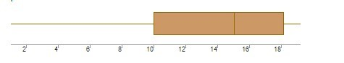

* What can we say about the distribution of the data?

Answer: Non-Symmetric distribution (median > mean) ➢ What is nature of skewness of the data?

Answer: Negative Skewed

* What will be the IQR of the data (approximately)?

Answer:

Q1 = 10, Q3 = 18

Q3-Q1 = 18-10 = 8

Q19) Comment on the below Boxplot visualizations?

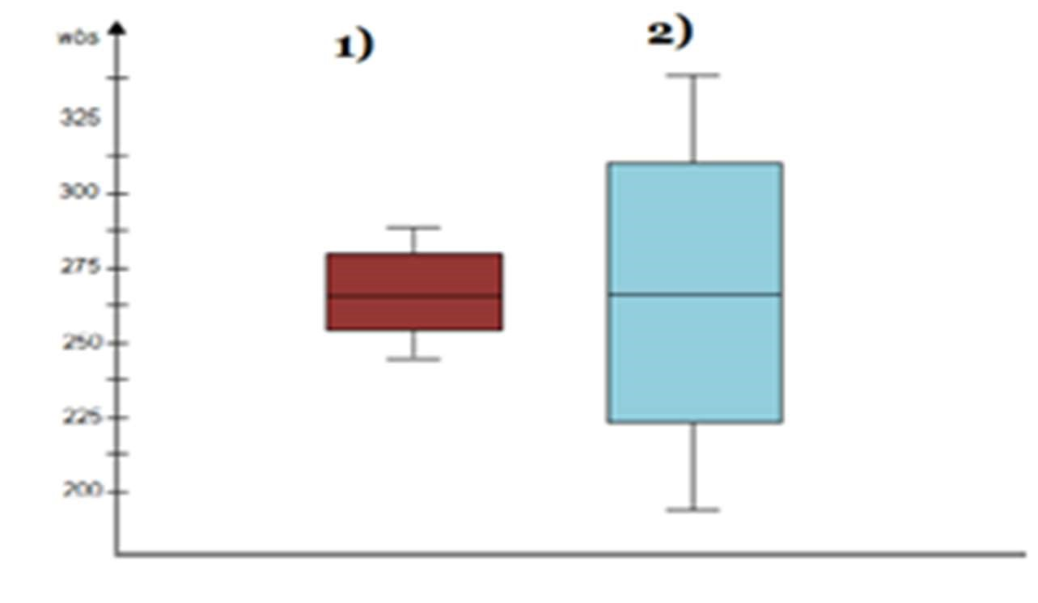

Draw an Inference from the distribution of data for Boxplot 1 with respect Boxplot

2.

Answer:

* In first boxplot the median is closer to Q1 so that this positively skewed i.e., Mean & median is greater than mode.
* In second boxplot median is in the middle where mean = median so there is symmetric distribution.

Q 20) Calculate probability from the given dataset for the below cases

Data _set: Cars.csv

Calculate the probability of MPG of Cars for the below cases.

MPG <- Cars $ MPG

* 1. P(MPG>38)
  2. P(MPG<40)
  3. P (20<MPG<50)

Answer:

1. P(MPG>38) = 0.34750288929863415
2. P(MPG<40) = 0.7294349739243934
3. P(20<MPG<50) = 0.8988805681995043

Q 21) Check whether the data follows normal distribution

1. Check whether the MPG of Cars follows Normal Distribution Dataset: Cars.csv

Answer: as per the calculation data has not Normal Distribution.

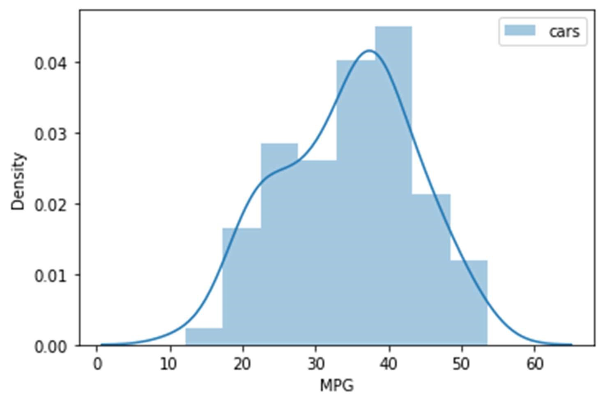

1. Check Whether the Adipose Tissue (AT) and Waist Circumference (Waist) from wc-at data set follows Normal Distribution. Dataset: wc-at.csv

Answer: As per the calculation data has not Normal Distribution.

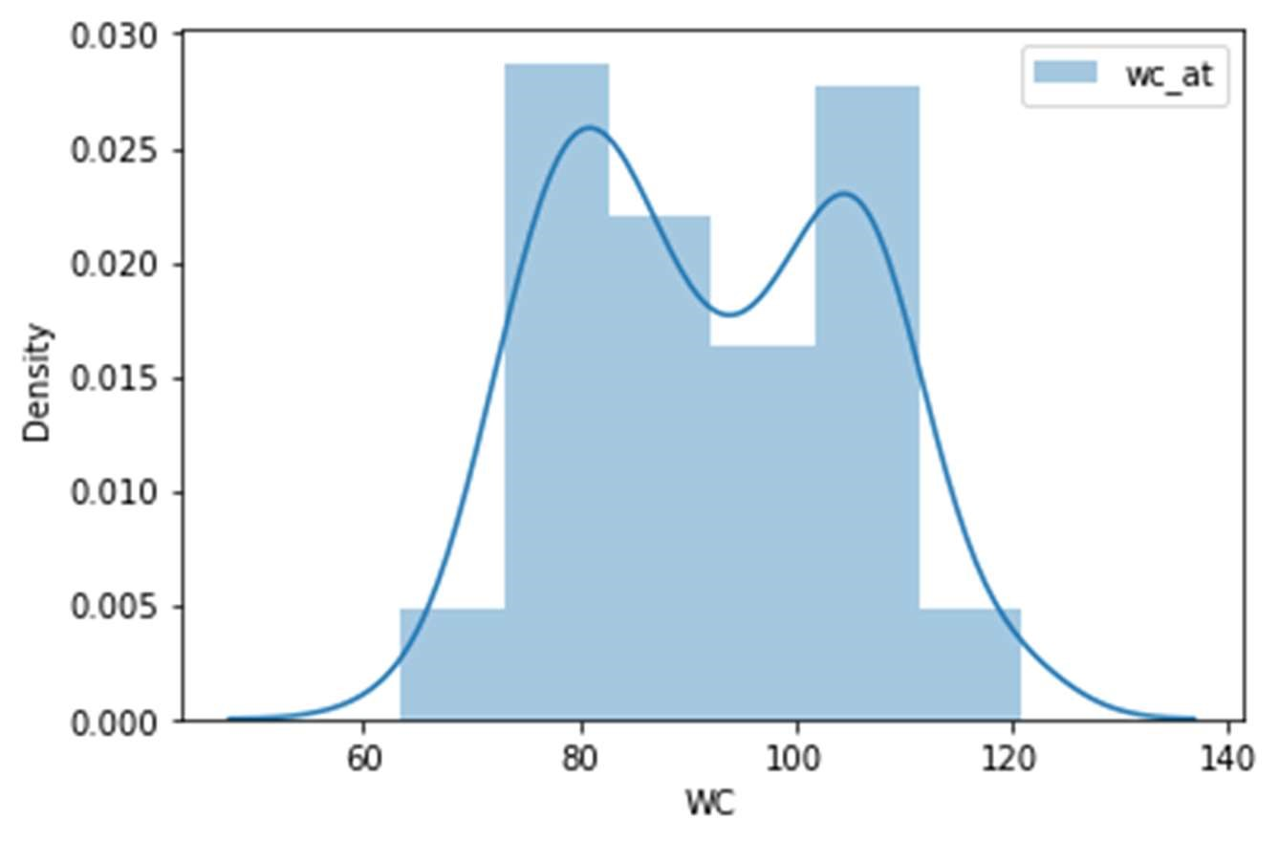

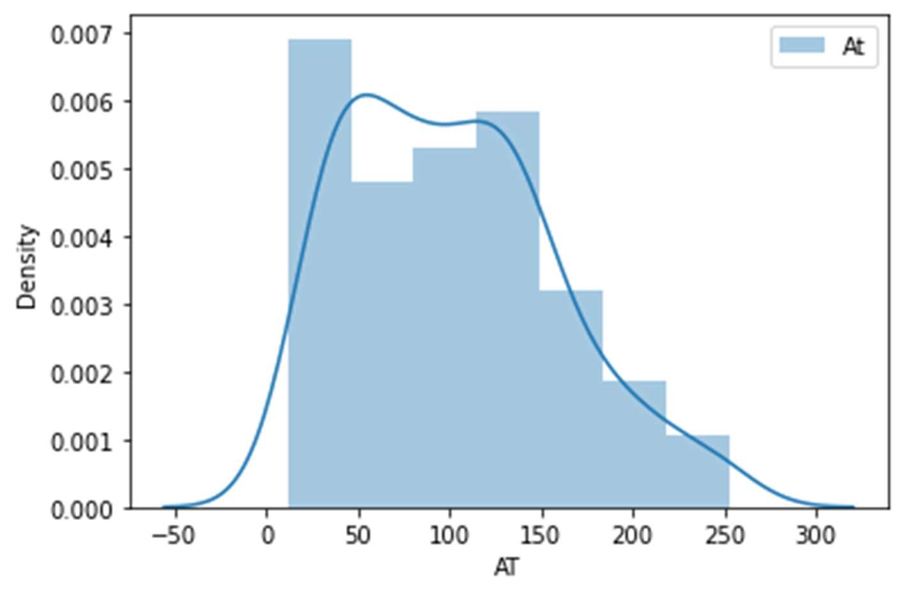

Q 22) Calculate the Z scores of 90% confidence interval,94% confidence interval, 60% confidence interval.

Answer:

|  |  |
| --- | --- |
| percentage | Confidence Interval |
| 90 | 1.959963984540054 |
| 94 | 1.8807936081512509 |
| 60 | 0.8416212335729143 |

Q 23) Calculate the t scores of 95% confidence interval, 96% confidence interval, 99% confidence interval for sample size of 25

Answer:

|  |  |
| --- | --- |
| percentage | Confidence Interval |
| 95 | 2.0638985616280205 |
| 96 | 1.8807936081512509 |
| 99 | 0.8416212335729143 |

Q 24) A Government company claims that an average light bulb lasts 270 days. A researcher randomly selects 18 bulbs for testing. The sampled bulbs last an average of 260 days, with a standard deviation of 90 days. If the CEO's claim were true, what is the probability that 18 randomly selected bulbs would have an average life of no more than 260 days.

Answer:

Rcode → pt (tscore, df)

df → degrees of freedom

Ans) µ=270, $\overline{x}$ =260, SD=90, n=18, df=n-1=18-1= 17

tscore= $\frac{\overline{x}-µ}{s/\sqrt{n}}$ = $\frac{260-270}{90/\sqrt{18}}$ = -10/21.23= -0.47

> pt(-0.47,17)

[1] 0.3221639

Required probability = 0.32=32%